**What is a Data Lake ?**

Repository of structured and unstructured files.

Large distributed cheap storage system like Hadoop hdfs, gcs

Not all data is structured which can fit in data warehouse like Teradata, BigQuery, Hive

In database in data warehouse the data , metadata, query engine and performance is all available by the warehouse vendor but the tech stack is all internal and within the paradigm of the provider.

Also all these features are available only when you load the data in the structured data warehouse.

ACID if any is only guaranteed only when the data is available inside the warehouse.

For file outside the warehouse do not have ACID guarantees.

More demand to make a data lake more closer to a data warehouse with the flexibility of data lake where many open source tools can be used and no vendor lock in and more flexible file storage layer.

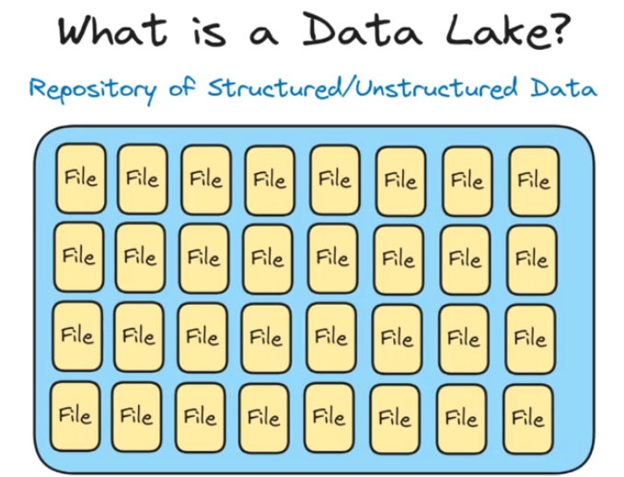

**What is a Table Format ?**

An abstraction to allow multiple files on the lake to be seen as a single table.

Flexibility to use many files in the data lake be part of a single table which can be referenced as a table and simple sql queries can be used to query the data. Same feature as was provided by data warehouse.

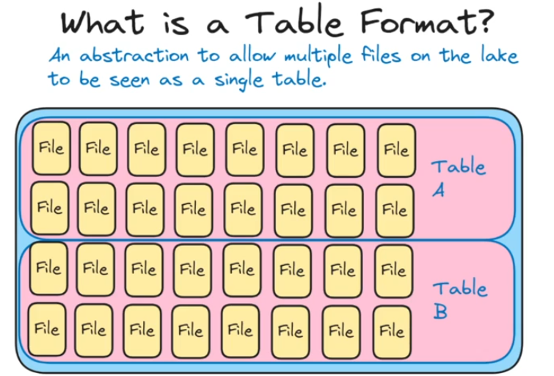

**How to table formats work ?**

Older hive engine worked with directory structures and partition structures and hive meta store tracked the tables and table locations.

In newer iceberg, hudi, delta lake table formats they track the actual files that make up the tables along with statistics on those columns in those files.

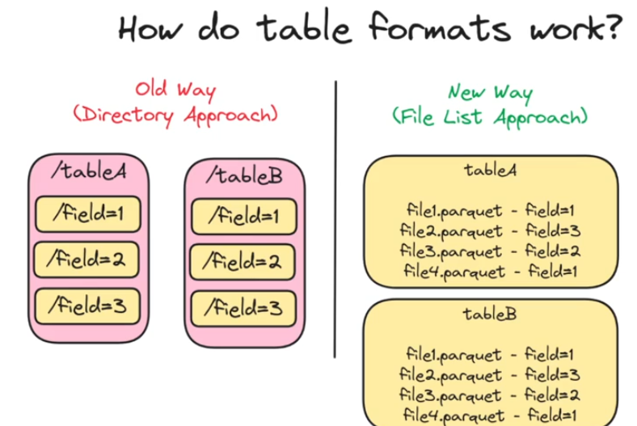

Open table format importance:

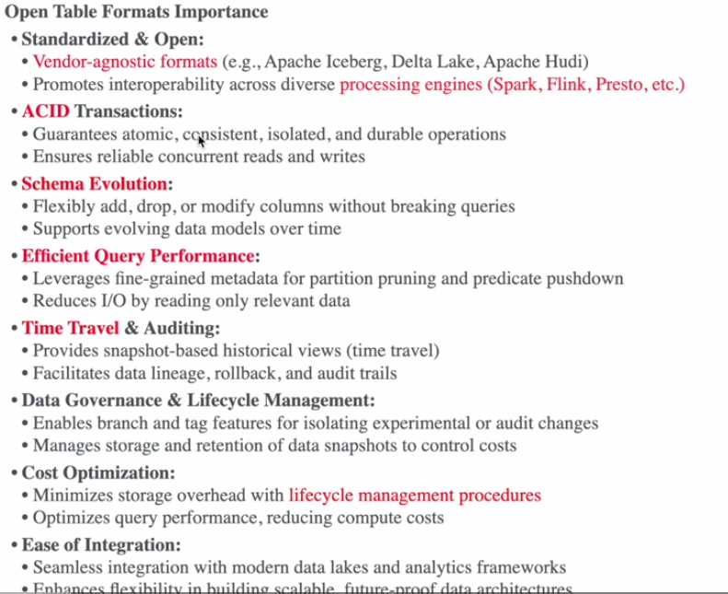

**Traditional Data warehouse vs New Data Lake (Lake house architecture):**

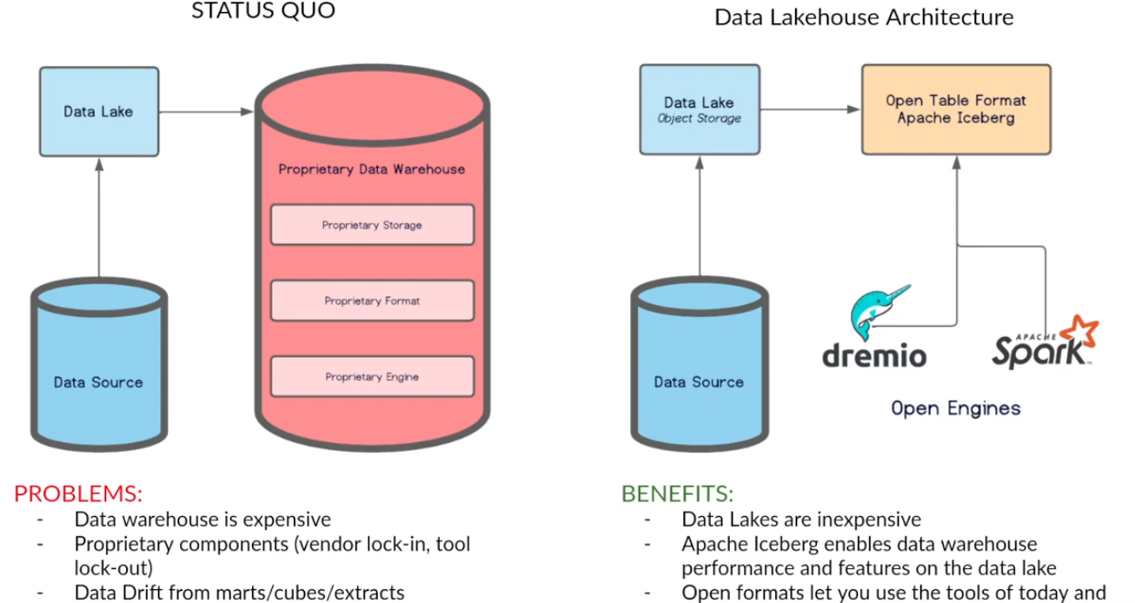

**Components of Data lake house:**

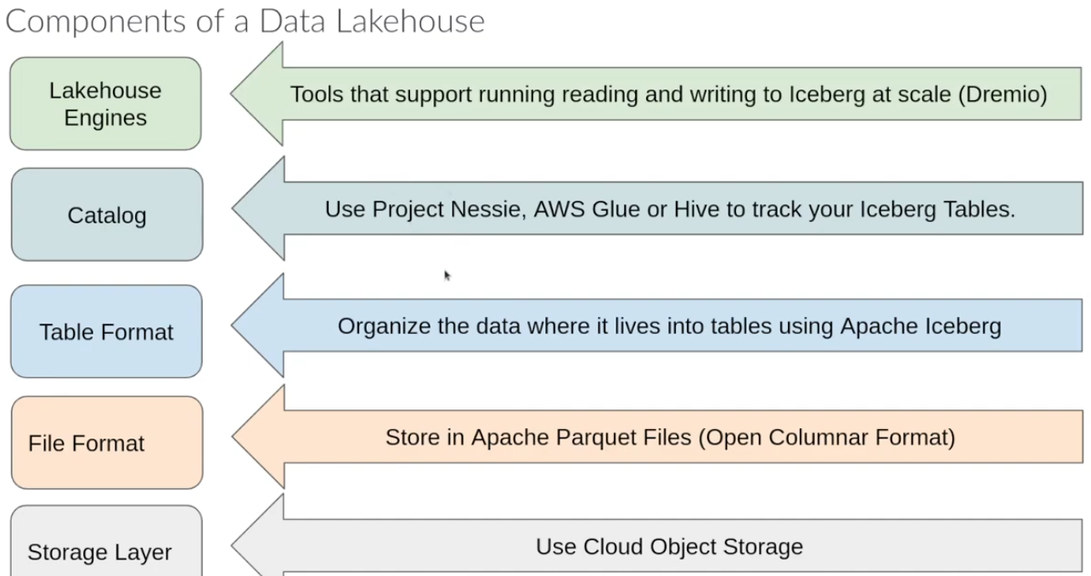

**What is Apache Iceberg ?**

Open table format. It provides the metadata standards which should be used by any engine which writes data or reads data.

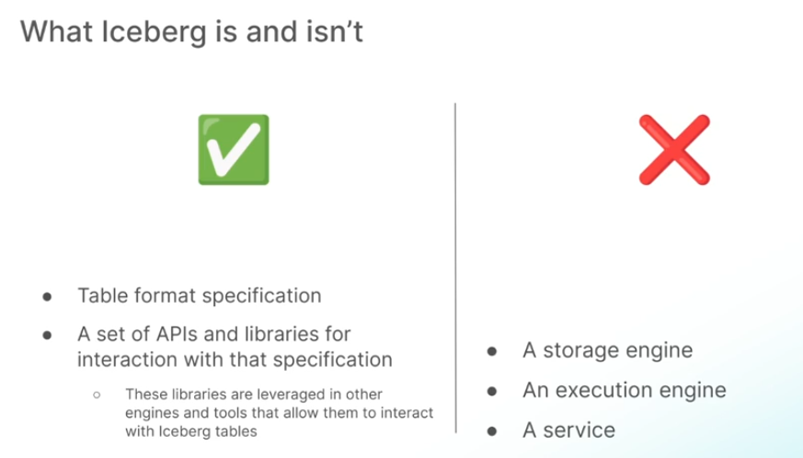

**How Iceberg works ?**

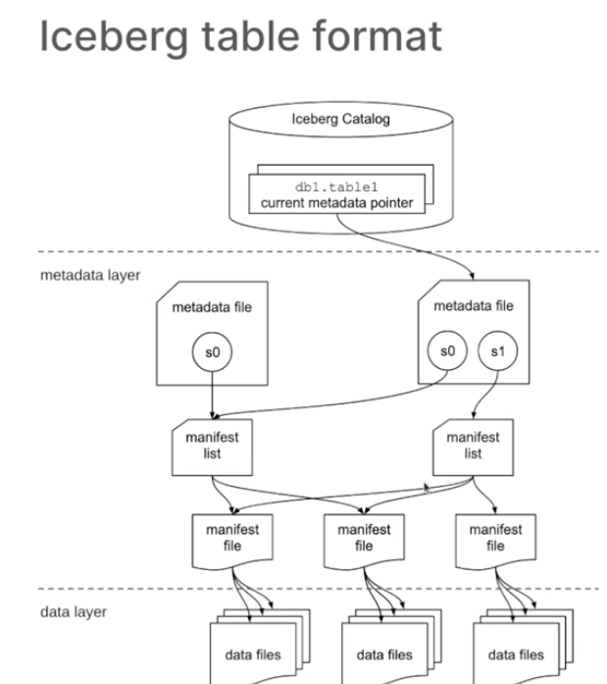

**What is iceberg snapshot?**

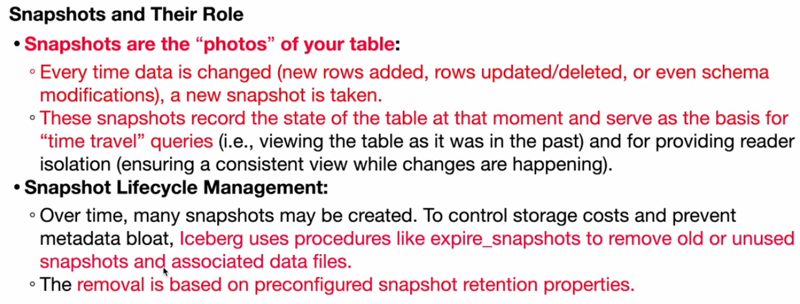

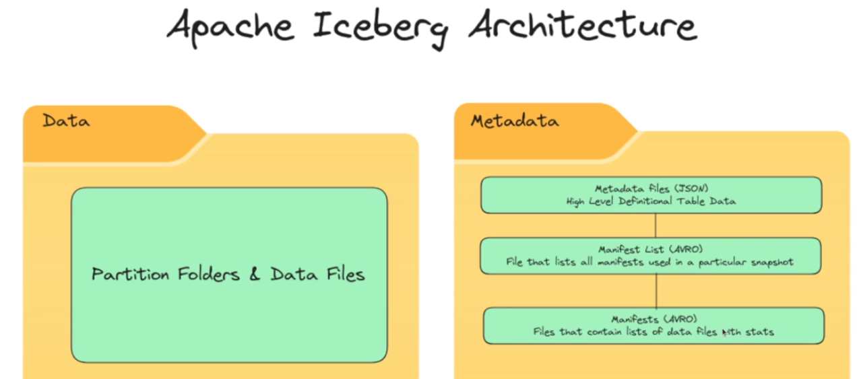

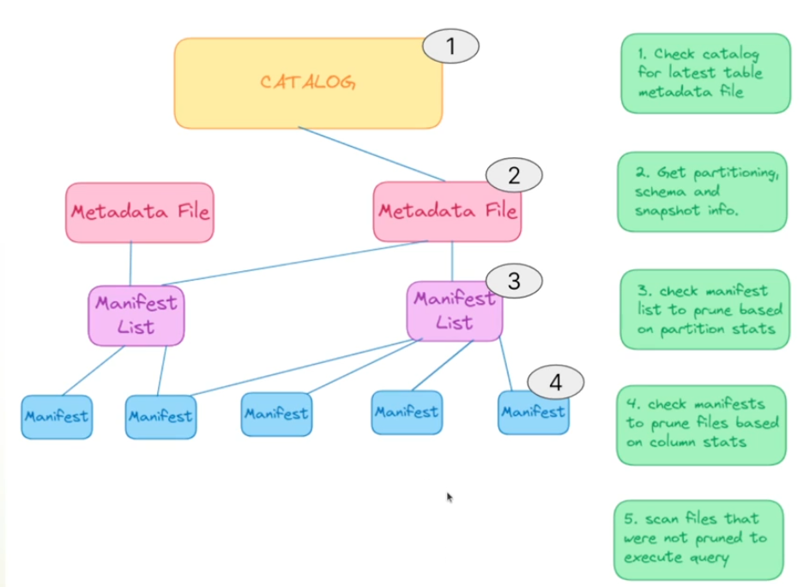

**Iceberg design benefits:**

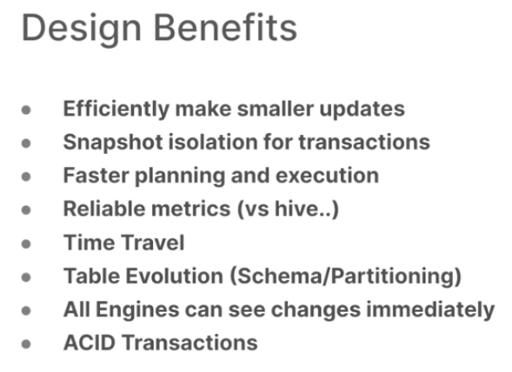

**Iceberg schema evolution**

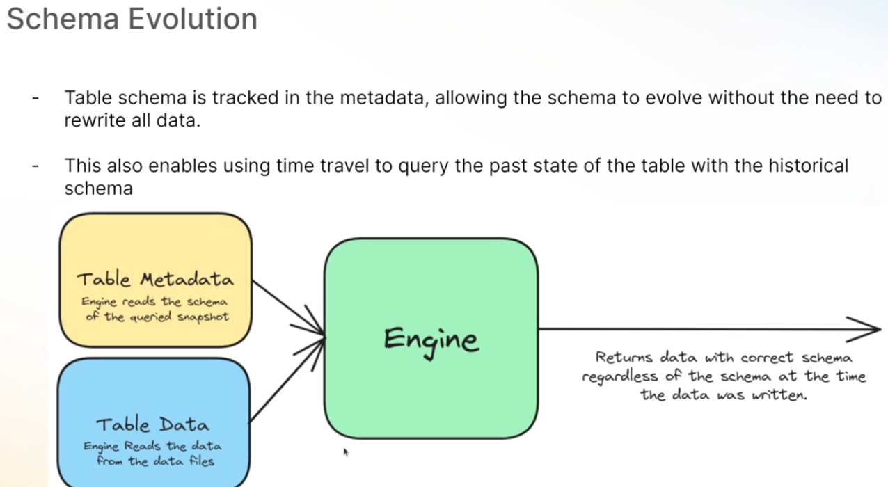

**Faster performance:**

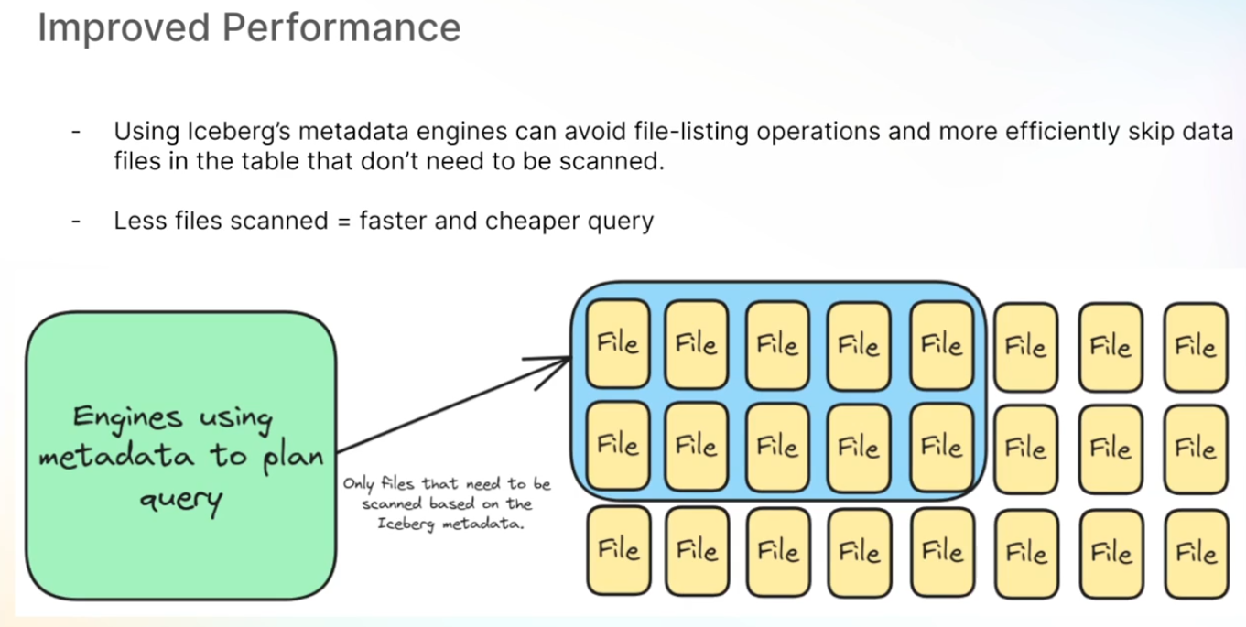

**Derived partition and partition evolution:**

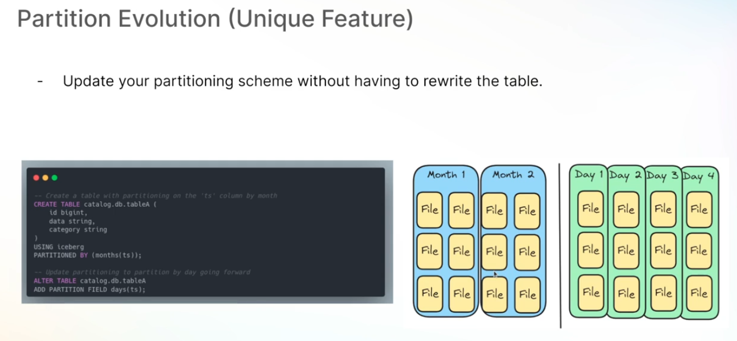

**Hidden partitioning:**

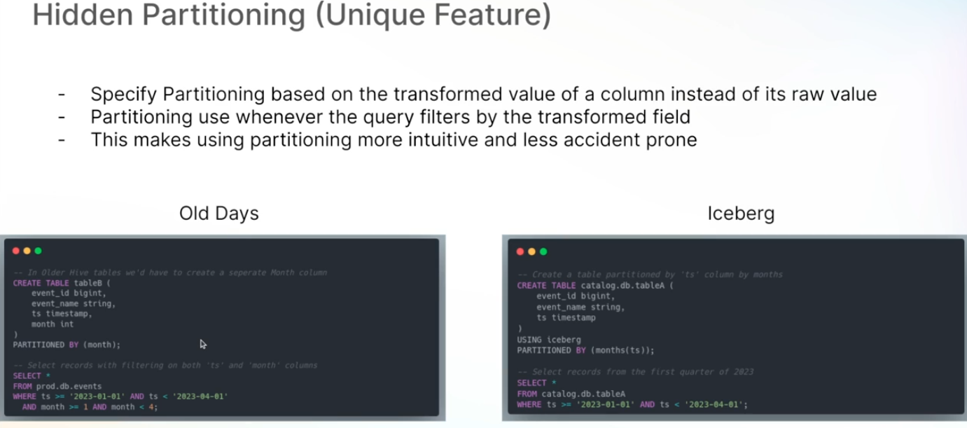

**Iceberg partitions:**

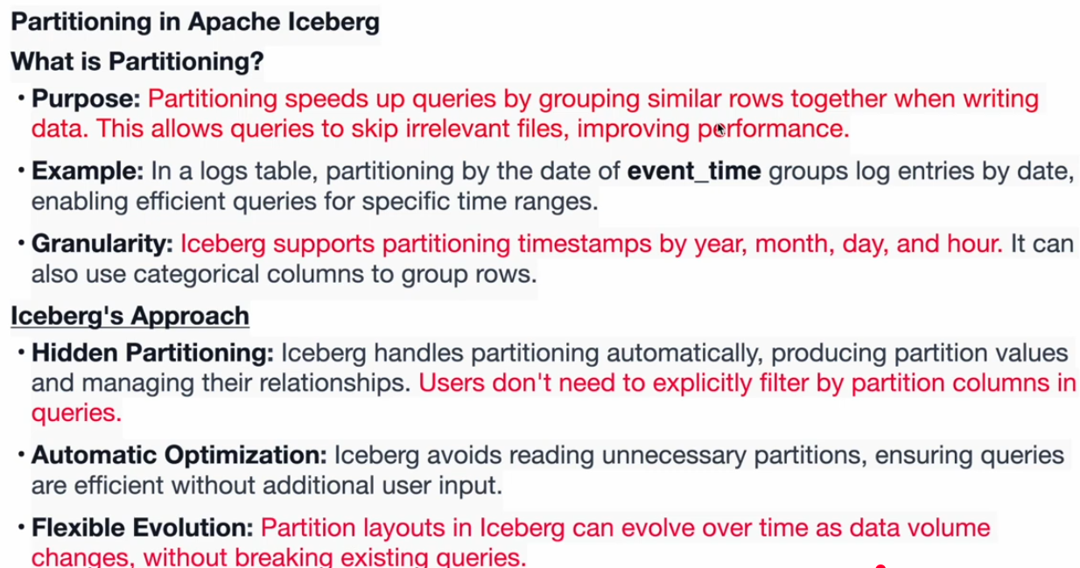

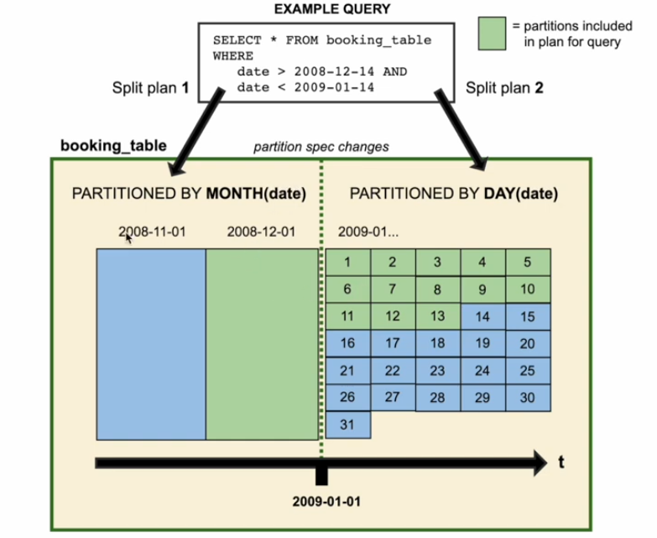

**Iceberg table maintenance:**

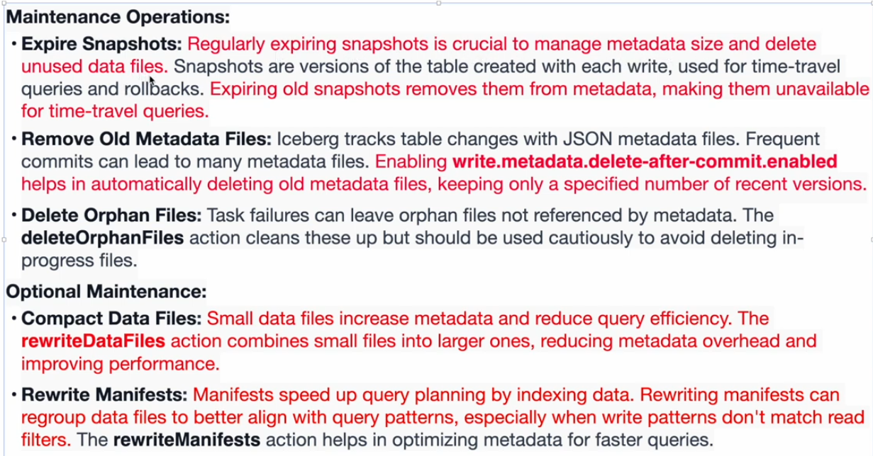

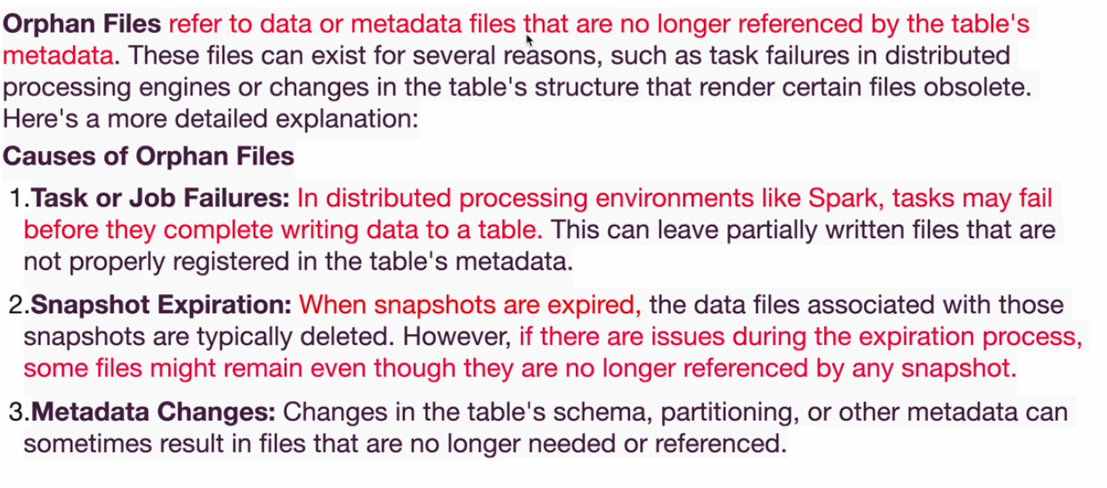

**Iceberg performance:**

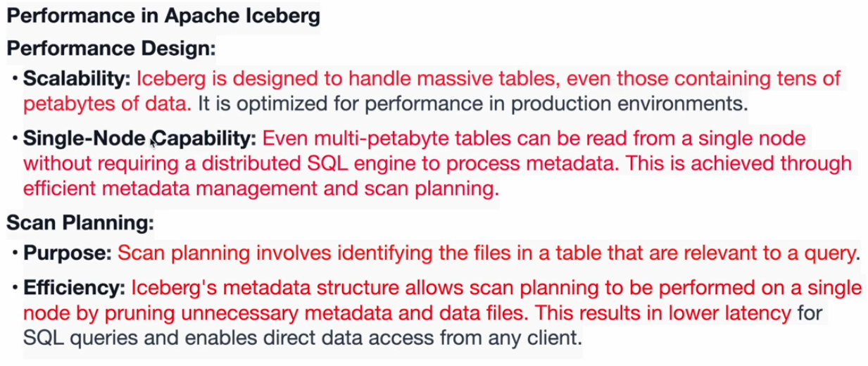

**Iceberg catalog**

